CAPSTONE PROJECT WORK REPORT
Phase I
Employee Task Management System Using Artificial Intelligence

MIRUTHIVKA B
(REG. NO. 2428C0486)
A report submitted in partial fulfillment of the degree of
B.Sc. Artificial Intelligence and Machine Learning

Under the Guidance of
Dr. S.R.Lavanya M.C.A., M.Phil., Ph.D.
Associate Professor, Dept. of AI and ML

Department of Artificial Intelligence and Machine Learning KPR College of Arts Science and Research

(Affiliated to Bharathiar University, Coimbatore) Avinashi Road, Arasur, Coimbatore-641407

March 2026

CAPSTONE PROJECT WORK REPORT
Phase I
Employee Task Management System Using Artificial Intelligence
Bonafide Work Done by

MIRUTHIVKA B REG. NO. 2428C0486
Dissertation submitted in partial fulfillment of the requirements for the award of
B.Sc. Artificial Intelligence and Machine Learning of Bharathiar University, Coimbatore-46.

Signature of the Guide Signature of the HOD

Submitted for the Viva-Voce Examination held on

Internal Examiner External Examiner

March 2026
Acknowledgment

I am writing this acknowledgment to express my deepest gratitude for the support and guidance you have provided me during the course of my capstone project.

I would like to convey my profound gratitude to Dr. P. Geetha, Principal of KPR College of Arts Science and Research, for her endless support. I would also like to extend my sincere thanks to Dr. M. Pradeepa,Dean, School of Intelligent System and Data Science, and our beloved Dr. R. Kumuthaveni M.C.A., M.Phil., Ph.D. Associate Professor & Head, Dept. of AI and ML, for providing moral support and motivation throughout the project.

It's my privilege to thank Dr. S.R.Lavanya Associate Professor, Department of Artificial Intelligence and Machine Learning, for her valuable support and suggestions. I feel privileged to have had the opportunity to learn from her, and I am grateful for the valuable lessons and experiences that I have gained under her guidance.

Student Signature,

Place: Coimbatore Date:

CONTENTS

Section No. | Section Title | Page No.
 | Acknowledgment | 2
 | Contents | 3
 | Synopsis | 4
1. | Introduction  - Organization Profile  - System Specification  - Hardware Configuration  - Software Specification | 5-8
2. | System Study  - Existing System  - Drawbacks  - Proposed System  - Features | 9-11
3. | System Design and Development  - File Design  - Input Design  - Output Design  - Database Design  - System Development  - Description of Modules (Detailed Explanation+) | 12-18
4. | Software Testing and Implementation | 19-22
5. | Conclusion & Future enhancement | 23-24
6. | Bibliography | 25-26
7. | Appendices  - Data Flow Diagram  - Table Structure  - Sample Coding  - Sample Input  - Sample Output | 27-32

Employee Task Management System Using Artificial Intelligence

Synopsis

The Employee Task Management System Using Artificial Intelligence is a web-based application developed to simplify and improve the process of assigning, managing, and tracking tasks within an organization. In many companies, task allocation is handled manually, which can lead to inefficiencies, incorrect assignments, and increased workload for managers. This system introduces an automated and intelligent approach where managers can log in, register employees by entering details such as employee name, ID, experience, previous company, gender, and password, and then assign tasks by specifying the task name and description. All data is securely stored in a MySQL database, ensuring easy access, organization, and management of employee and task information.
Employees can log in using their credentials and view the tasks assigned to them, helping them clearly understand their responsibilities and complete their work efficiently. A key feature of this system is the integration of Artificial Intelligence, which assists in making better task assignment decisions by analyzing employee experience and past performance to suggest the most suitable person for a task. The system is developed using HTML, CSS, JavaScript, and Bootstrap for the frontend, and PHP with MySQL for the backend. Overall, this project reduces manual effort, minimizes errors, improves transparency, and enhances productivity, while also providing scope for future improvements using advanced AI techniques.
The system also ensures data security by implementing proper authentication methods, which protect employee and task information from unauthorized access. It supports real-time updates, allowing both managers and employees to view the latest task details instantly without delays. The application is designed with a responsive interface, making it accessible across various devices such as laptops, tablets, and smartphones. Additionally, the system is scalable and can be enhanced in the future by incorporating features like notifications, performance analysis, and advanced AI-based task prediction techniques.
Furthermore, the system improves overall organizational efficiency by streamlining communication between managers and employees through a centralized platform. It reduces dependency on manual methods such as emails or paper-based tracking, ensuring better accuracy and organization of data. The AI component also helps in optimizing resource utilization by matching tasks with the most suitable employees based on their skills and experience. This not only enhances productivity but also contributes to employee satisfaction by assigning tasks that align with their capabilities.
In addition, the system provides better monitoring and control over task progress, enabling managers to easily track assigned work and ensure timely completion. It helps in maintaining a structured record of all activities, which can be useful for future analysis and decision-making. The centralized database simplifies data management and reduces redundancy, making the system more reliable and efficient. Overall, the application creates a more organized workflow environment, improving coordination and effectiveness within the organization.

1.Introduction
In today’s digital world, organizations require efficient systems to manage employee tasks and improve productivity. Traditional methods of task assignment are often manual, time-consuming, and prone to errors. Managers may find it difficult to assign the right task to the right employee due to lack of proper data analysis and tracking systems.
The integration of Artificial Intelligence (AI) enhances the system by helping in decision-making. It analyzes employee details such as experience and past performance to suggest the most suitable employee for a particular task. This improves efficiency and ensures better utilization of human resources.
The system is developed using modern web technologies such as HTML, CSS, JavaScript, Bootstrap for the frontend, PHP for backend processing, and MySQL for database management. It provides a user-friendly interface and ensures smooth interaction between managers and employees.

Project Objectives
The objective of this project is to develop a web-based system for efficient employee task management. It aims to automate the process of assigning tasks and improve productivity using Artificial Intelligence. The system also provides secure login and allows employees to easily view their assigned tasks.
• Automate Task Assignment: To reduce manual workload by automating the process of assigning tasks from managers to employees through the system, ensuring faster and more efficient task allocation.
• Implement Secure Login System: To provide secure authentication for both managers and employees using login credentials such as username, employee ID, and password, ensuring data privacy and protection.
• Manage Employee Information: To create a system that allows managers to register, store, and manage employee details such as name, ID, experience, gender, and previous company in an organized manner.
• Enable Task Tracking: To allow employees to view their assigned tasks clearly, including task name and description, helping them understand their responsibilities and complete tasks effectively.
• Integrate Artificial Intelligence: To use AI techniques to analyze employee data and suggest the most suitable employee for a given task based on experience, skills, and performance.
• Improve Productivity and Efficiency: To enhance organizational productivity by assigning tasks effectively, reducing errors, and ensuring proper utilization of employee skills.

Significance of the Project
Overall, this project is significant as it demonstrates how modern technologies and AI can be used to solve real-world problems in task management, making organizations more efficient, organized, and productive.

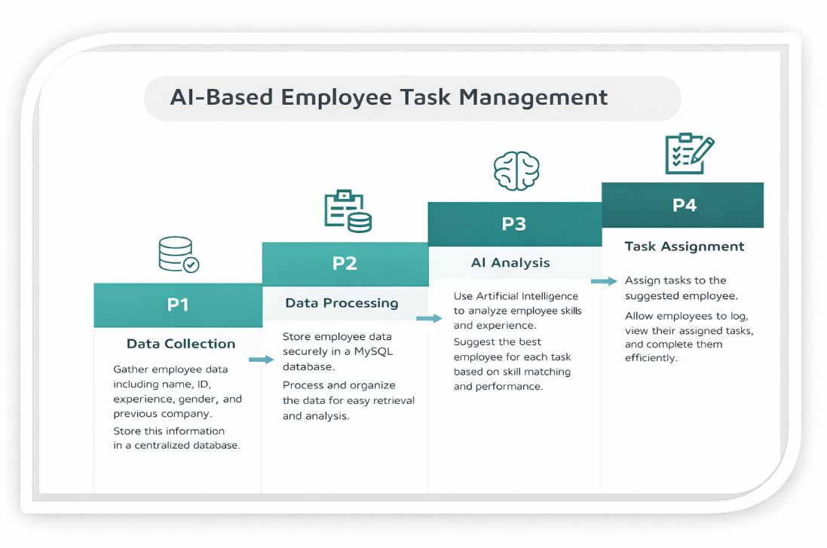
Organization Profile
KPR College of Arts Science and Research (KPRCAS) is a premier institution in Tamil Nadu, established in 2019 under the prestigious KPR Group. Affiliated with Bharathiar University, Coimbatore, the college is dedicated to academic excellence, innovation, and industry-oriented education. Situated in Arasur, Coimbatore, KPRCAS provides a world-class learning environment with a strong emphasis on research and practical knowledge application.

Vision and Mission
Vision: To be a globally recognized institution that imparts knowledge and life skills to students, shaping them into responsible citizens who contribute to society’s growth and development.

Mission:
- To provide high-quality education that blends theoretical and practical knowledge.
- To equip students with industry-relevant skills and enhance employability.
- To promote research and development in emerging fields like Artificial Intelligence, Data Science, and Cybersecurity.
- To instill ethical values, leadership qualities, and lifelong learning habits in students.

Hardware Configuration

Component | Details
Laptop Model | Lenovo 82XF IdeaPad Slim 5i
Processor | Intel Core i5 (13th Gen)
RAM | 16GB
GPU | Intel Integrated
Storage | 512 GB (SSD)
Display | 40.64 cm (16 inch)

Software Specification

Component | Details
Operating System | Windows 11 Home
Development Environment | VS Code
Programming Language | Python
Libraries | NumPy, Pandas, scikit-learn, Streamlit, joblib ,Matplotlib, Seaborn

2 .System Study
The system study of the Employee Task Management System Using Artificial Intelligence involves analyzing the current methods used for task assignment and identifying their limitations. In many organizations, tasks are assigned manually or through basic tools like spreadsheets and emails, which often leads to inefficiencies, miscommunication, and lack of proper tracking. There is no centralized system to manage employee data or monitor task progress, making it difficult for managers to assign tasks based on employee skills and experience. This results in poor resource utilization and increased chances of errors.
To overcome these issues, the proposed system introduces a web-based solution that automates task management and improves decision-making through Artificial Intelligence. The system allows managers to register employees, store their details in a database, and assign tasks efficiently, while employees can log in to view their assigned work. The AI component helps in suggesting the most suitable employee for a task, ensuring better performance and productivity. Overall, the system study highlights the need for an intelligent, centralized, and user-friendly platform to enhance task management within organization.
2.1 Existing System
- Manual Task Assignment-Tasks are assigned manually by managers without using any automated system or intelligent analysis.

- Lack of Centralized Data-Employee details and task information are stored in different places like files or spreadsheets, making management difficult.

- Poor Tracking and Communication-There is no proper system to track task progress, leading to miscommunication and delays in work completion
The existing system for task management is mostly manual and lacks automation. Managers assign tasks based on personal judgment, and employee details are stored in spreadsheets or files, making the process time-consuming and unorganized. There is no proper system for tracking tasks or ensuring clear communication, which can lead to errors, delays, and reduced productivity.
  - Drawbacks of the Existing System
- .Time-Consuming Process-Task assignment and data management are done manually, which takes more time and reduces efficiency.

- Lack of Accuracy-Manual handling increases the chances of errors in assigning tasks and maintaining employee records

- Poor Task Tracking-There is no proper system to monitor task progress, leading to delays and incomplete work.

- No Intelligent Decision-Making-Tasks are assigned without analyzing employee skills or experience, resulting in improper task allocate

2.3 Proposed System
To address the limitations of the existing system, this project introduces an AI-driven Employee Task Management System that:
• Automates Task Assignment → Uses intelligent logic to assign tasks automatically based on employee details, reducing manual effort and errors.
• Improves Decision Making → Analyzes employee experience, previous work, and performance to assign tasks to the most suitable employee.
• Enhances Accessibility → Provides a user-friendly web application that can be accessed anytime through browsers on different devices.
• Ensures Data Management → Stores all employee and task information in a centralized MySQL database for easy access and organization.
• Provides Transparency → Allows employees to view their assigned tasks clearly, improving communication and understanding.
• Enables Scalability → The system can be extended with advanced AI models, notifications, and performance tracking features in the future.
2.4 Features
1 .Real-Time Task Updates → Provides instant updates when tasks are assigned, allowing employees to view their work immediately.
2. User-Friendly Interface → Developed using HTML, CSS, JavaScript, and Bootstrap, ensuring a simple and interactive experience for both managers.
3.AI-Based Decision Support → Analyzes employee data such as experience and past work to suggest the most suitable employee for each task.
4.Centralized Data Management → Stores employee details and task information in a MySQL database for easy access and organization.
5. Secure Login System → Provides authentication for managers and employees using username, employee ID, and password to ensure data security.
6.Task Tracking System → Allows employees to view assigned tasks clearly, including task name and description for better understanding.
7.Scalable and Web-Based → The system is accessible through a web browser and can be extended with features like notifications and performance tracking.

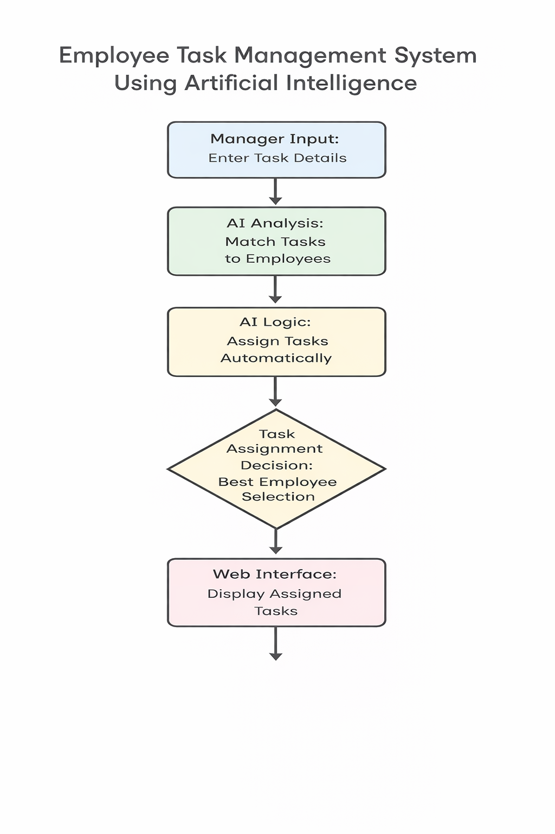

3. System Design and Development

3.1 File Design
The project consists of structured files for proper organization and easy maintenance. The key files include:
1.Backend File (task_management.php / app.py)
• Handles login, employee registration, and task assignment.
2. Frontend Files (HTML, CSS, JS)
• Provides user interface for manager and employee.
• Includes welcome page, login page, and dashboard.
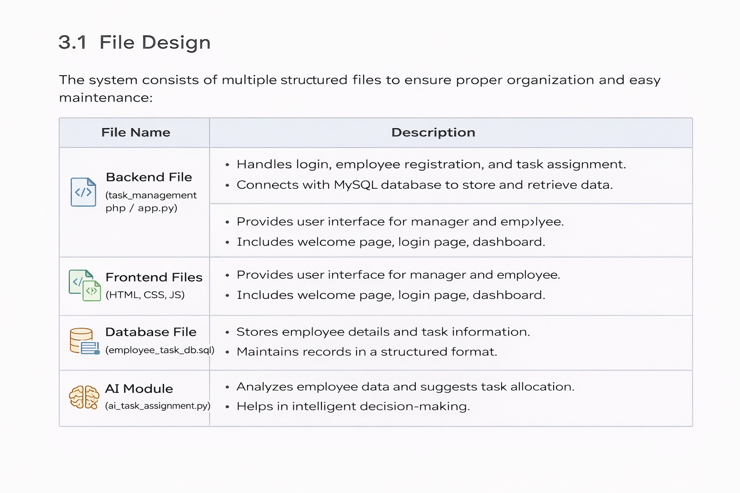
3. Database File (employee_task_db.sql)
• Stores employee details and task information.
• Maintains records in a structured format.
4. AI Module (ai_task_assignment.py)
• Analyzes employee data and suggests task allocation.
• Helps in intelligent decision-making.

3.2 Input Design
The system requires employee and task-related details as input, which are provided by the manager through a web-based interface.
1.Input Parameters:
• Employee Name / ID
• Task Name
• Task Description
• Task Priority (High / Medium / Low)
• Assigned Date
• Due Date
• Task Status (Pending / In Progress / Completed)
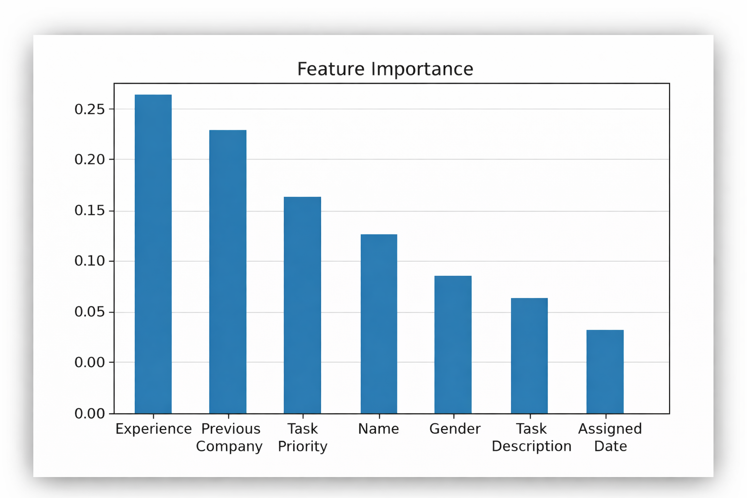
2. Input Processing:
• Data Validation: Ensures all required fields are correctly filled
• Input Formatting: Maintains proper format for dates and text fields
• Data Verification: Confirms employee details before task assignment
• Error Handling: Displays messages for missing or invalid inputs

3.3 Output Design
The system manages and tracks employee tasks based on assigned details.
1.Task Output Categories:
• Completed → Task is successfully finished by the employe
• In Progress → Task is currently being worked on.
• Pending → Task is assigned but not yet started.
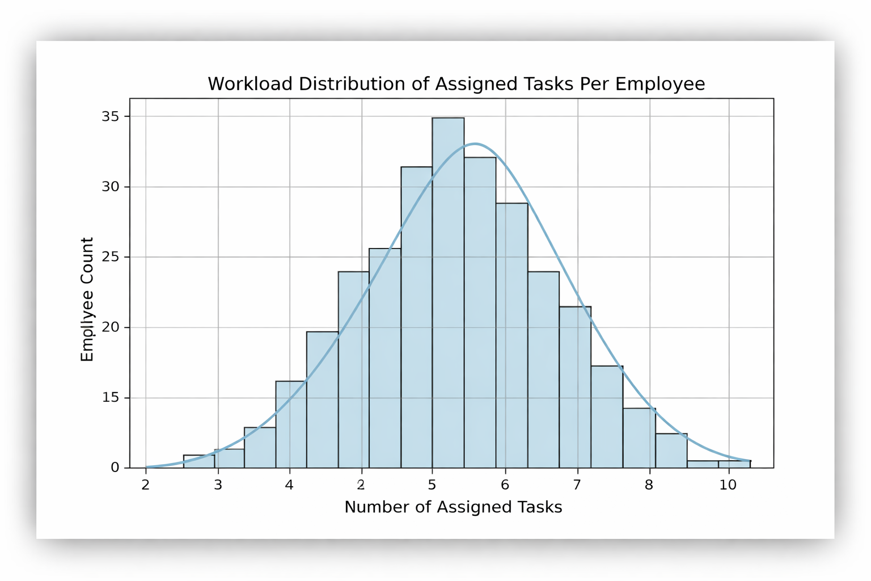
Output Display:
• Real-time task status display on the dashboard.
• Task details and progress updates visible to both manager and employee.
• Report generation and CSV download for record-keeping and analysis.

3.4 Database Design
The system relies on structured data for managing employees and task assignments.
Dataset Used:
• Employee_Task_Dataset.xlsx – Contains employee details and assigned task records.
1.Data Storage:
• Data is stored in database tables (Employee, Task, Assignment).
• Task reports and summaries are saved in CSV format for analysis.
2.Data Processing Techniques:
• Handling Missing Values → Ensures all required fields are completed before submission
• Data Validation → Checks correctness of employee and task details.
• Data Organization → Stores data in structured tables for easy access and management.

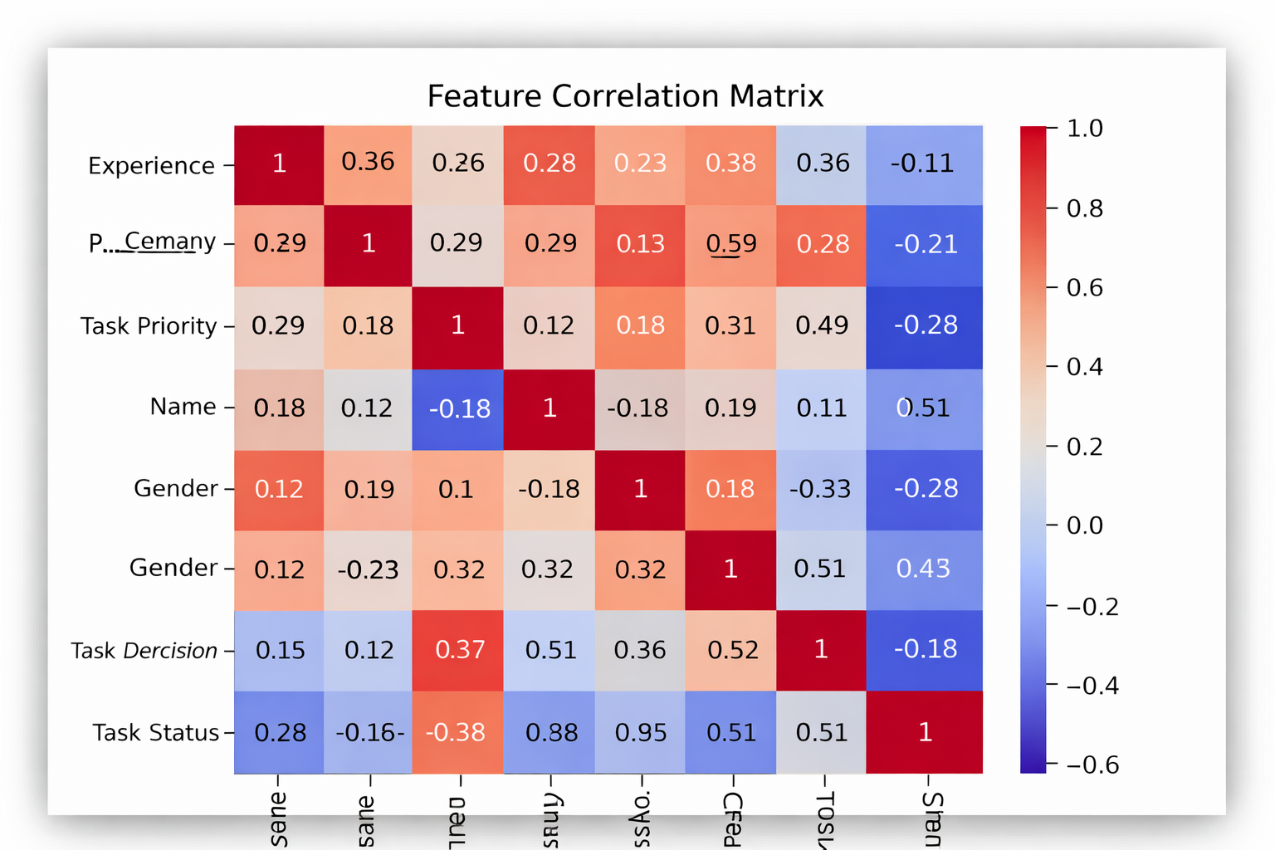

3.5 System Development

1. Development Methodology
• Follows an agile approach for iterative development.
• Includes requirement analysis, design, implementation, testing, and deployment.

2. Technology Stack
• Programming Language: Python / PHP
• Frontend: HTML, CSS, JavaScript, Bootstrap
• Backend Framework: Flask / Node.js
• Database: MySQL / SQLite
• Deployment: Local Server / Cloud (AWS, Google Cloud)

3. Data Processing & Management
• Handles missing data by validating user inputs.
• Organizes employee and task data in structured tables.
• Ensures data consistency and accuracy for task tracking.

4. System Development
• Implements modules for employee registration and login.
• Develops task assignment and tracking features.
• Allows updating task status (Pending, In Progress, Completed).
• Ensures smooth interaction between manager and employee.
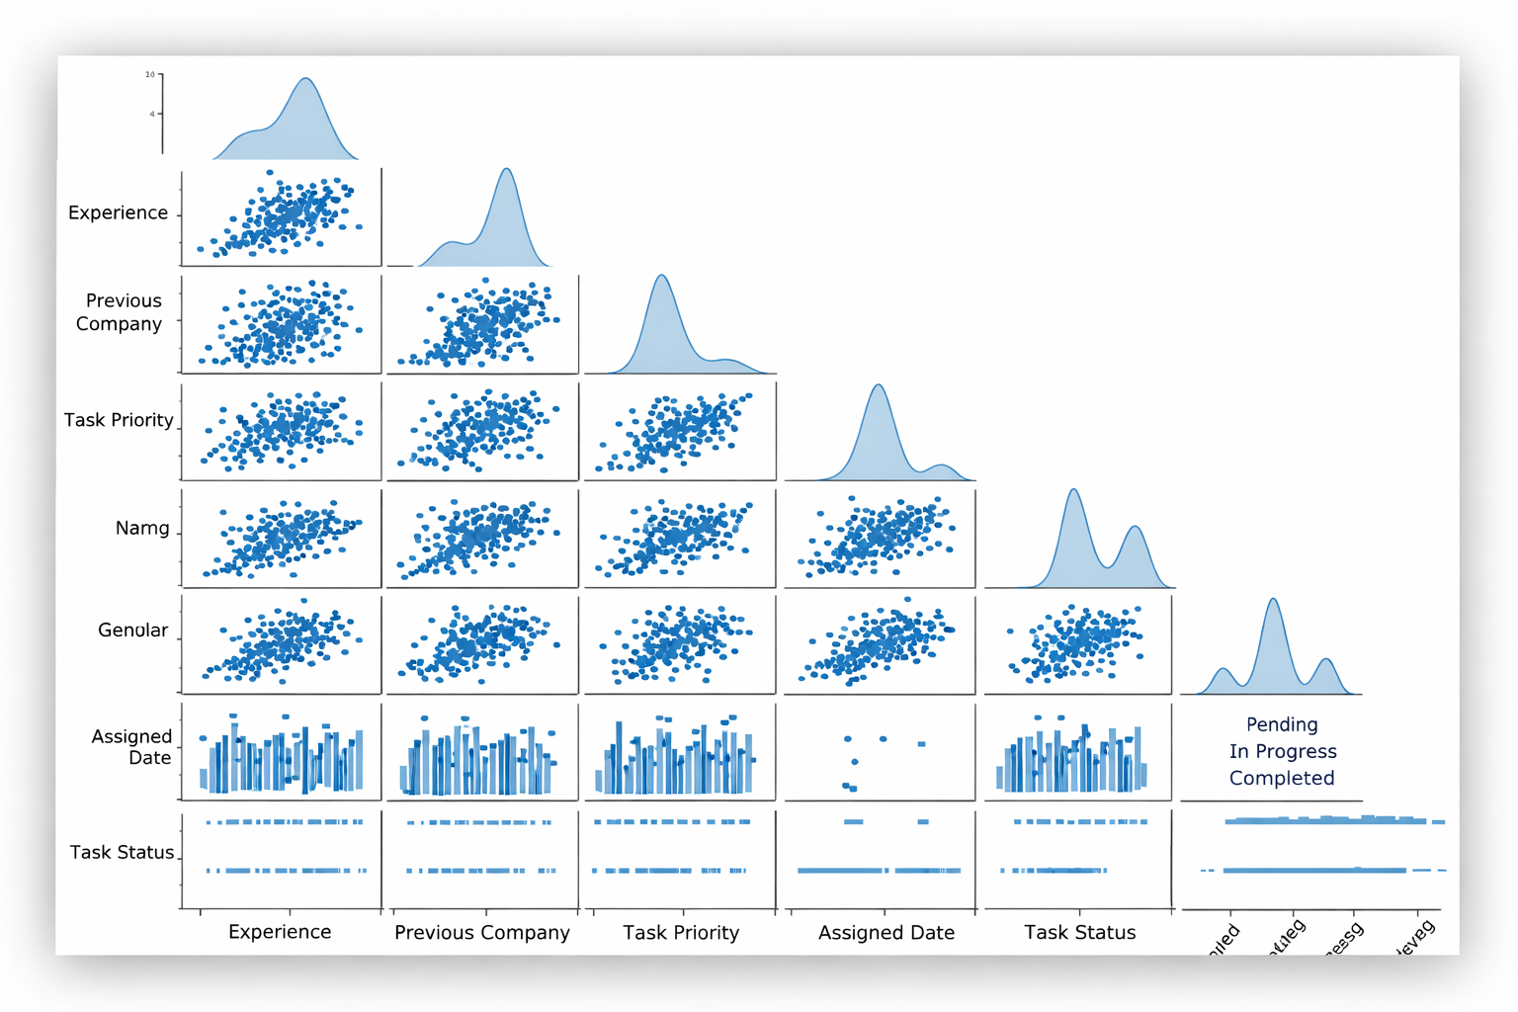

5. Web Application Development
• Frontend: User-friendly interface for managers and employees.
• Backend: Handles task assignment, updates, and data storage.
• Features: Task creation, status tracking, and report generation.

6. System Integration & Testing
• Unit Testing: Verifies individual modules like login and task assignment.
• Integration Testing: Ensures proper data flow between frontend and database.
• Performance Testing: Checks system speed and usability.

7. Deployment & Maintenance
• Deploys application on local server or cloud platforms.
• Regular updates and bug fixes for smooth functioning.
• Monitors system performance and ensures data security.

3.6 Description of Modules (Detailed Explanation)
The system is structured into key functional modules, each responsible for managing and tracking employee tasks efficiently. Below is a detailed explanation of each module:
1. User Management Module
This module handles employee and manager account management within the system.
• Registers new employees and managers with required details.
• Manages login and authentication for secure access.
• Stores user information such as name, email, role, and password.
• Ensures only authorized users can access the system.
• Allows profile updates and password changes.

2. Task Assignment Module
This module is responsible for assigning tasks to employees by the manager.
• Allows managers to create and assign tasks to employees.
• Captures task details like task name, description, priority, and deadlines.
• Ensures tasks are assigned to the correct employee.
• Updates task allocation records in the database.
• Notifies employees about newly assigned tasks.

3. Task Tracking & Management Module
This module manages the progress and status of assigned tasks.
• Allows employees to view their assigned tasks.
• Enables updating task status (Pending, In Progress, Completed).
• Tracks progress of each task in real time.
• Helps managers monitor employee performance.
• Maintains history of completed and pending tasks.

4. Web Application Module
This module provides a user-friendly interface for interaction with the system.
• Developed using HTML, CSS, JavaScript, and backend framework.
• Provides dashboard for both managers and employees.
• Allows task creation, assignment, and status updates.
• Displays task details in a clear and structured format.
• Ensures responsive design for desktop and mobile devices.

5. Reporting & Performance Monitoring Module
This module analyzes task data and generates reports for decision-making.
• Generates reports on task completion and employee performance.
• Displays summaries such as completed, pending, and overdue tasks.
• Allows downloading reports in CSV format.
• Helps managers evaluate productivity and efficiency.
• Tracks system usage and performance over time

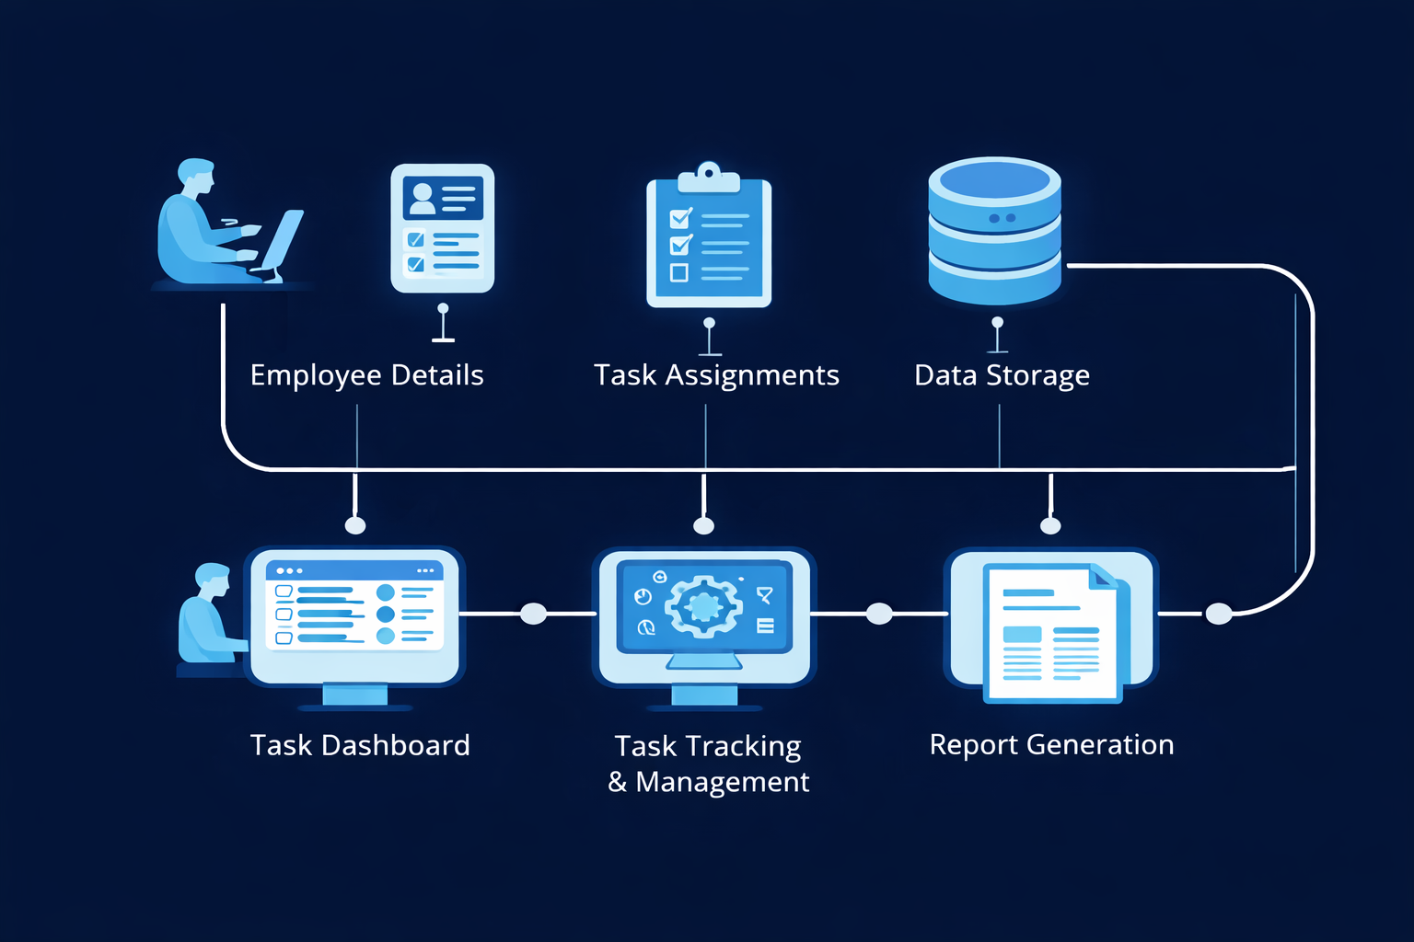

4. Software Testing and Implementation

4.1 Testing Strategies
To ensure the reliability, performance, and efficiency of the Employee Task Management System, multiple testing methodologies are applied:

1. Unit Testing
Tests individual components such as employee registration, login module, task assignment, and task update functions.

2. Integration Testing
Tests interaction between different modules such as admin dashboard, employee module, and database.

3. Functional Testing
Ensures all system functionalities meet the requirements.
Validates features such as:
  - Employee login/logout
  - Task assignment by manager
  - Task status updates (Pending / In Progress / Completed)

4. Performance Testing
Measures system response time when multiple users access the system.

5. Usability Testing
Ensures the user interface is simple and easy to use.

6. Security Testing
Ensures secure login using authentication (username & password).

7. Regression Testing
Performed after adding new features or fixing bugs.
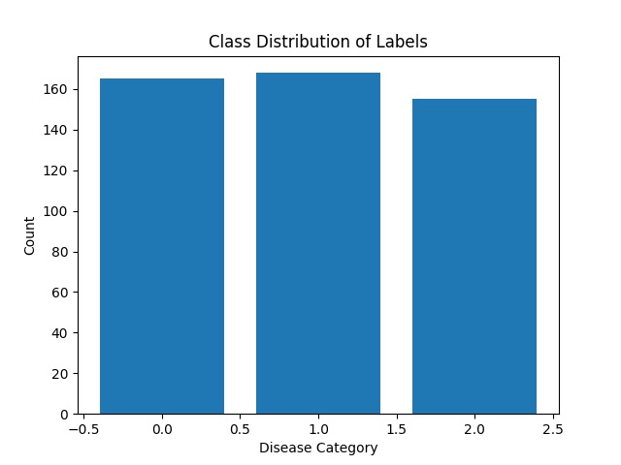

Streamlit Frontend Development
• Design an interactive Streamlit UI for:
¬ Adding and managing employee details.
¬ Assigning tasks with task name, description, deadline, and priority.
¬ Displaying task status (Pending / In Progress / Completed).
¬ Viewing employee-wise and task-wise reports.
• Integrate backend logic directly into app.py for task assignment and tracking.
• Ensure cross-platform compatibility (desktop, tablet, mobile).
• Implement real-time updates for task status changes.
• Enable downloading task reports in CSV format for analysis.

Deployment & Hosting
• Deploy the web application using:
¬ Streamlit Community Cloud (for quick deployment).
¬ AWS / Google Cloud (for scalable enterprise deployment).
• Optimize server configurations for handling multiple users.
• Implement CI/CD pipelines for:
¬ Automated testing and validation.
¬ Continuous deployment and updates.
¬ Fixing bugs without downtime.

3.7 Quality Assurance & Debugging

1. Error Handling Mechanisms
• Detects and handles invalid or missing employee/task details.
• Prevents duplicate task assignments.
• Logs system errors for debugging and improvements.

2. Continuous Monitoring
• Tracks system usage and task updates in real-time.
• Monitors application performance and response time.
• Ensures smooth operation without delays or crashes.

3. User Feedback Integration
• Collects feedback from employees and managers.
• Improves UI/UX based on user suggestions.
• Updates features based on real-world usage.

4. Automated Testing Framework
• Uses PyTest for unit and functional testing.
• Tests task assignment, updates, and report generation.
• Ensures system reliability before deployment. 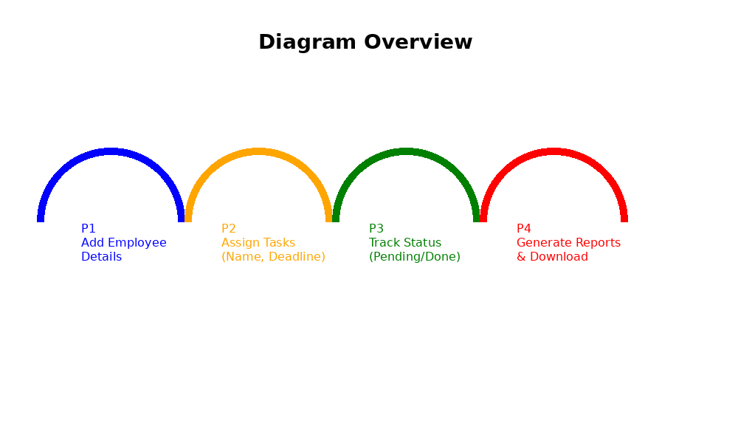

5. Conclusion
The development of this Employee Task Management System demonstrates the effectiveness of digital solutions in improving workplace productivity and task organization. By integrating a structured task assignment process with an interactive web-based interface, this project successfully provides a reliable, efficient, and user-friendly platform for managing employee activities.

Key Highlights of the Project
➢ Efficient Task Management System → The system allows managers to assign, monitor, and manage tasks effectively, ensuring better workflow organization.
➢ Improved Performance & Productivity → Organized task allocation helps employees focus on their responsibilities, improving overall efficiency.
➢ User-Friendly Interface → A simple and interactive interface makes it easy for both managers and employees to use the system without technical difficulty.
➢ Secure Login & Role Management → Separate login access for managers and employees ensures data privacy and proper role-based control.
➢ Reliable Functionality & Testing → The system is tested to ensure smooth performance, accurate task assignment, and error-free operation.
➢ Scalability & Flexibility → The system can be expanded with additional features such as notifications, deadlines, and progress tracking.
➢ Real-World Applicability → This system can be used in companies and organizations to streamline task distribution and improve team coordination.

Future Enhancements
• Adding Task Deadlines & Reminders → Implementing deadline tracking and automated notifications to ensure timely task completion.
• Real-Time Task Updates → Enabling live updates so managers can monitor task progress instantly and employees can update their work status.
• Performance Analytics Dashboard → Introducing analytics to evaluate employee performance, task completion rate, and productivity trends.
• Mobile & Cloud Integration → Expanding the system to mobile applications and cloud platforms for remote access and better scalability.
• Role-Based Access Enhancement → Improving security by adding advanced role management such as admin, manager, and employee levels.
• Collaboration Features → Adding team communication tools like comments, file sharing, and discussion boards within tasks.
• AI-Based Task Recommendations → Integrating AI to suggest task priorities and assign tasks based on employee skills and workload.

Final Thoughts
The implementation of a digital Employee Task Management System highlights the importance of technology in improving organizational efficiency and workflow management. This project serves as a practical solution for managing tasks, enhancing communication, and ensuring accountability within teams.
By incorporating advanced features such as real-time tracking, analytics, and AI-based enhancements, the system can evolve into a comprehensive productivity tool. With further development and scalability, this project has the potential to transform how organizations manage their workforce, bridging the gap between traditional management methods and modern digital solutions.

Bibliography
- Pressman, R. S. (2014). Software Engineering: A Practitioner’s Approach. McGraw-Hill Education.
- Sommerville, I. (2016). Software Engineering (10th Edition). Pearson Education.
- Duckett, J. (2011). HTML and CSS: Design and Build Websites. Wiley Publications.
- Flanagan, D. (2020). JavaScript: The Definitive Guide. O’Reilly Media.
- Grinberg, M. (2018). Flask Web Development: Developing Web Applications with Python. O’Reilly Media.
- Ramalho, L. (2015). Fluent Python. O’Reilly Media.
- Welling, L., & Thomson, L. (2017). PHP and MySQL Web Development. Addison-Wesley.
- Elmasri, R., & Navathe, S. (2016). Fundamentals of Database Systems. Pearson.
- Silberschatz, A., Korth, H. F., & Sudarshan, S. (2019). Database System Concepts. McGraw-Hill.
- Mozilla Developer Network (MDN). (2024). Web Development Documentation. Retrieved from https://developer.mozilla.org
- W3Schools. (2024). HTML, CSS, JavaScript Tutorials. Retrieved from https://www.w3schools.com
- Bootstrap Documentation. (2024). Bootstrap Framework Guide. Retrieved from https://getbootstrap.com
- Python Software Foundation. (2024). Python Documentation. Retrieved from https://docs.python.org
- Streamlit Documentation. (2024). Streamlit Web App Framework. Retrieved from https://streamlit.io
- MySQL Documentation. (2024). MySQL Database Reference Manual. Retrieved from https://dev.mysql.com/doc
- Google Developers. (2024). Web Development Best Practices. Retrieved from https://developers.google.com
- Stack Overflow Community. (2024). Programming Discussions and Solutions. Retrieved from https://stackoverflow.com

Appendices

Data Flow Diagram

Start
↓
Login
↓
Valid User?
↓ ↓
Yes No
↓ ↓
Dashboard Error Message
↓
Role (Manager / Employee)
↓
Manager → Assign Task → Save → Logout
Employee → View Task → Update Status → Logout
↓
End

B. Table Structure
The table structure represents the dataset used in the Employee Task Management System, typically stored in a database or managed using tools like Microsoft Excel or MySQL. It contains multiple columns representing various attributes related to employees and task management.The dataset includes fields such as Employee ID, Employee Name, Department, Task ID, Task Name, Task Description, Assigned Date, Due Date, Task Priority, Task Status, and Manager Name. Each row in the table corresponds to a specific task assigned to an employee.The structure is organized in a tabular format, making it easy to store, retrieve, and manage task-related information efficiently. The data is mostly textual and date-based, with some categorical values such as task priority (High, Medium, Low) and task status (Pending, In Progress, Completed).his structured dataset is essential for tracking employee performance, monitoring task progress, and ensuring efficient workflow management within the organization.

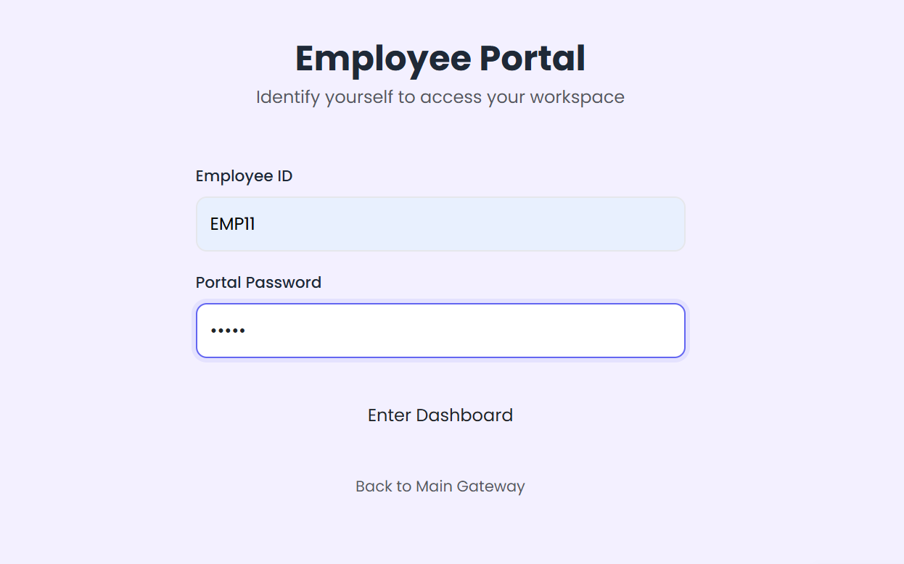

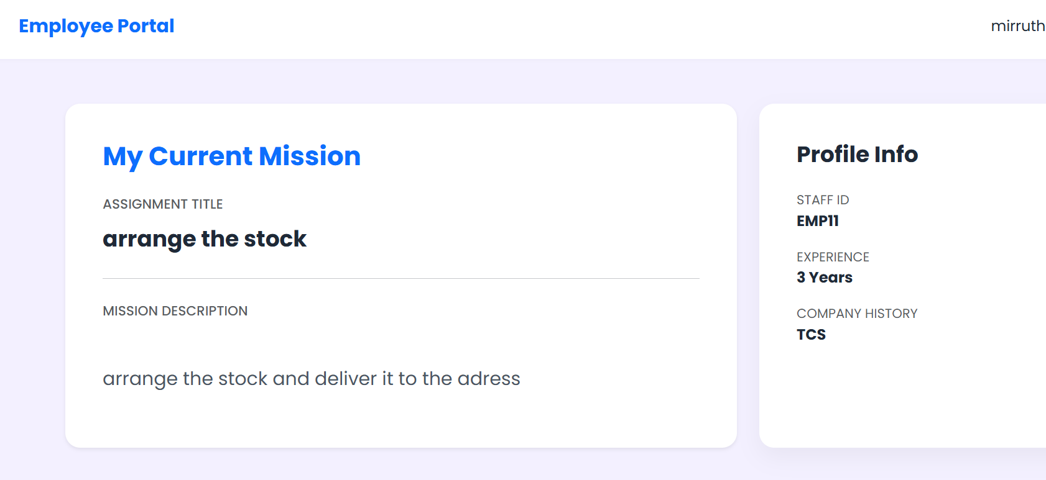
C. Sample Coding

1. task_management_model.py (Task Data Processing & Saving)

import pandas as pd
import joblib
from sklearn.model_selection import train_test_split
from sklearn.ensemble import RandomForestClassifier
from sklearn.metrics import accuracy_score
# Load dataset
df = pd.read_csv("Employee_Task_Dataset.csv")
# Features and target
X = df.drop(columns=["Task_Status"]) # Features
y = df["Task_Status"] # Target (Pending/In Progress/Completed)
# Split dataset
X_train, X_test, y_train, y_test = train_test_split(
X, y, test_size=0.2, random_state=42
)
# Model
model = RandomForestClassifier(n_estimators=100, random_state=42)
model.fit(X_train, y_train)
# Prediction & Accuracy
y_pred = model.predict(X_test)
accuracy = accuracy_score(y_test, y_pred)
print(f"Model Accuracy: {accuracy:.2f}")
# Save model
joblib.dump(model, "task_model.pkl")
print("Model saved successfully!")

app.py (Streamlit App for Task Management)

import streamlit as st
import pandas as pd
import joblib
# Load model
model = joblib.load("task_model.pkl")
# Title
st.title("Employee Task Management System")
# Upload file
uploaded_file = st.file_uploader("Upload Task Data (CSV)", type=["csv"])
if uploaded_file is not None:
data = pd.read_csv(uploaded_file)
st.write("### Uploaded Data Preview")
st.write(data.head())
# Prediction
if st.button("Check Task Status"):
predictions = model.predict(data)
data["Predicted Status"] = predictions
st.write("### Task Status Results")
st.write(data)
# Download
data.to_csv("task_results.csv", index=False)
st.download_button("Download Results", "task_results.csv")

1. Model Output (task_management_model.py)
Model Accuracy: 0.90
The model was saved successfully as 'task_model.pkl'

2. Streamlit UI Output (app.py)
Web App Interface
- Title: Employee Task Management System
- Upload CSV Section
- Display Uploaded Data
- "Check Task Status" Button
- Download Results Option

D. Sample Input
Uploaded CSV Sample (User Input):
Employee_ID | Task_ID | Task_Priority | Task_Deadline_Days | Work_Hours
101 | 201 | 1 | 2 | 5
102 | 202 | 2 | 5 | 3
103 | 203 | 3 | 1 | 8

E. Sample Output
Predicted Output:
Employee_ID | Task_ID | Task_Priority | Task_Deadline_Days | Work_Hours | Predicted Status
101 | 201 | 1 | 2 | 5 | In Progress
102 | 202 | 2 | 5 | 3 | Pending
103 | 203 | 3 | 1 | 8 | Completed

Download Option
A "Download Results" button allows users to download the task status results as a CSV file.

  - .

